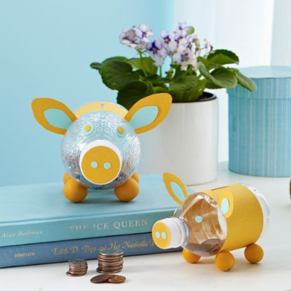

What you need:
- Empty plastic water or fizzy bottle (the wider the better)
- Craft knife
- Scissors
- Coloured paper (2 sheets of two different colours)
- Pencil
- School glue
- sello tape
- Hole punch
- Paintbrush
- Ear templates (download at allyou.com/piggybank) or use appropriately sized triangles.
- 4 large wooden beads (for feet)
What you do:
- Peel label off clean, empty bottle. Use craft knife to cut an approximately 4x1 cm wide slot (for inserting coins) in bottle, about midway between top and bottom.
- Use scissors to cut a strip of orange paper long enough to wrap around bottle and same width as bottle label. Wrap paper around bottle and use a pencil to trace over slot in bottle. Unwrap paper and cut slot with craft knife.
- Use scissors to cut out triangular shaped ears. Leave extra paper at the bottom of the ear to create a tab (about 1 cm). Repeat. You can cut smaller triangles out of your other coloured paper to create an inner ear. You won’t need an extra tab. Glue inner ear to outer ear. Fold outer ears at tab. Position ears along edge of paper band, about 2.5 cms to each side of slot. Tape tabs to back of paper band. Wrap band with ears around bottle, aligning slots on bottle and paper. Overlap ends of band and tape seam.
- Trace around bottle cap on coloured paper. Cut out and glue to cap. Use hole punch to make 2 circles in the coloured paper. Glue to bottle cap.
- For eyes, use hole punch to make 2 circles of either color. Glue them to bottle. Or, cut 2 10 cent piece sized circles out of contrasting paper and glue hole-punch circles to them; glue larger circles to bottle.
- For legs, glue the four wooden beads to "belly" side of bottle and let dry.

